IN723 Lab 7 BGP Aggregate

In this lab we will configure and observe the behavior of the BGP aggregate-address command.
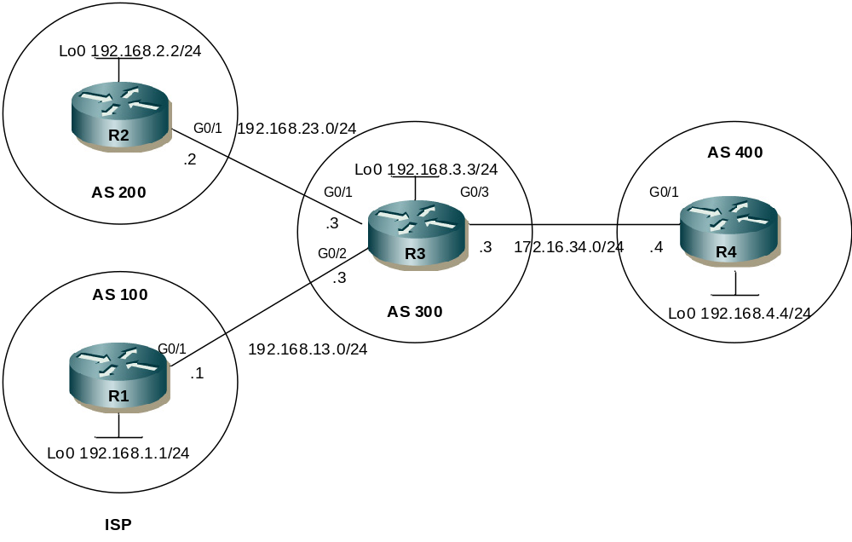

- Note – This lab cannot be completed in packet tracer (unsupported BGP commands). You can use VIRL, GNS3 or the physical lab (if 4 routers available).
- You may need to clear BGP sessions or issue a soft reset for some changes to take effect

Step 1 - Physical
- Physically cable the lab as per the above diagram using 1841 / 1941 routers & crossover cables.

Step 2 – IP addressing
- Configure IP addressing as per the network diagram.
- Ensure to configure the loopback interfaces.

Step 3 – EBGP Peering
- Configure fixed BGP router-ids on R1, R2, R3 and R4 using the loopback IP addresses
- Configure EBGP between R1 and R3 using the WAN interfaces for peering
- Configure EBGP between R2 and R3 using the WAN interfaces for peering
- Configure EBGP between R3 & R4 using the WAN interfaces for peering
- Use “show ip bgp neighbors” to confirm if route-refresh cability is supported and negotiated.
- What does route-refresh mean?
- Verify peer status with
show ip bgp summary

Step 4 – Advertise Networks
- Advertise the WAN networks and Loopback networks via BGP on R1 & R2. Ensure the origin code is i
- View and record the bgp tables on R3 & R4

Step 5 – Aggregate
- Use the aggregate-address command on R3 to create a summary for 192.168.0.0/16. Ensure to advertise the aggregate and the specific prefix
router bgp 300
aggregate-address 192.168.0.0 255.255.0.0

- Confirm the summary and specifics are present in R4s BGP table. Note the AS-PATH of the summary prefix, how does this differ from the specifics?
- Change the aggregate-address command on R3 to adverise only the summary (not the specifics) and confirm in R4s BGP table

Step 6 – AS SET
- Change the aggregate-address command to use the as-set option while advertising only the summary
- Review the BGP table on R4, what does as-set do?
- What do the AS numbers in brackets mean?

Step 7 – Community
- Use an out bound route map on R1 to set the community value for R1s loopback as no-export. Note you need to configure BGP on R1 to send the community attribute.
route-map LO-COM permit 10
match ip address 1
set community no-export

route-map LO-COM permit 20

access-list 1 permit 192.168.1.0 0.0.0.255

router bgp 100
neighbor 192.168.13.3 send-community
neighbor 192.168.13.3 route-map LO-COM out

- Use the command “show ip bgp community no-export” on R3
- Review the BGP table on R4. What happened?

Step 8 – Attribute inheritance
- Change the aggregate-address command on R3 to use an advertise-map (along with as-set) to choose which prefixes to inherit attributes from. Ensure the prefixes are inherited from R2s loopback network.

route-map ADV-MAP permit 10
match ip address 2

access-list 2 permit 192.168.2.0 0.0.0.255

router bgp 300
aggregate-address 192.168.0.0 255.255.0.0 as-set summary-only advertise-map ADV-MAP

- Review the BGP table on R4. Has it changed?

Extension
- Configure R2 to set a community of 200:200 (using the new format) when advertising its loopback address to R3. Review the BGP table on R4, has the community value been inherited by the aggregate?
- Remove the aggregate-address command on R3. Configure R3 to prepend the AS-PATH by 2 instances of 300 for prefixes recieved from R2 that match the community of 200:200. Check the BGP table on R4, has the AS-PATH for R2’s loopback changed?
- Change the EBGP peering between the routers to use the loopback addresses.

